FOR NEW TREX USERS:

* Complete TEAL MODULES TRAINING GUIDES:
* <https://tea.texas.gov/reports-and-data/data-submission/texas-records-exchange-trex/trex-training>
* Apply for TEAL account at https://pryor.tea.state.tx.us/.

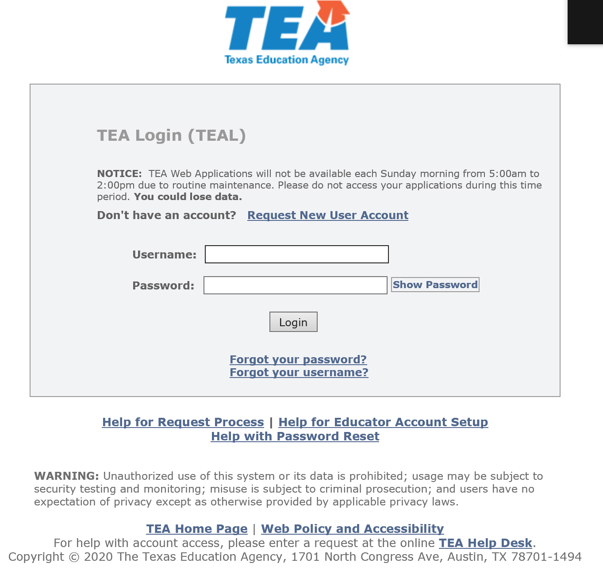

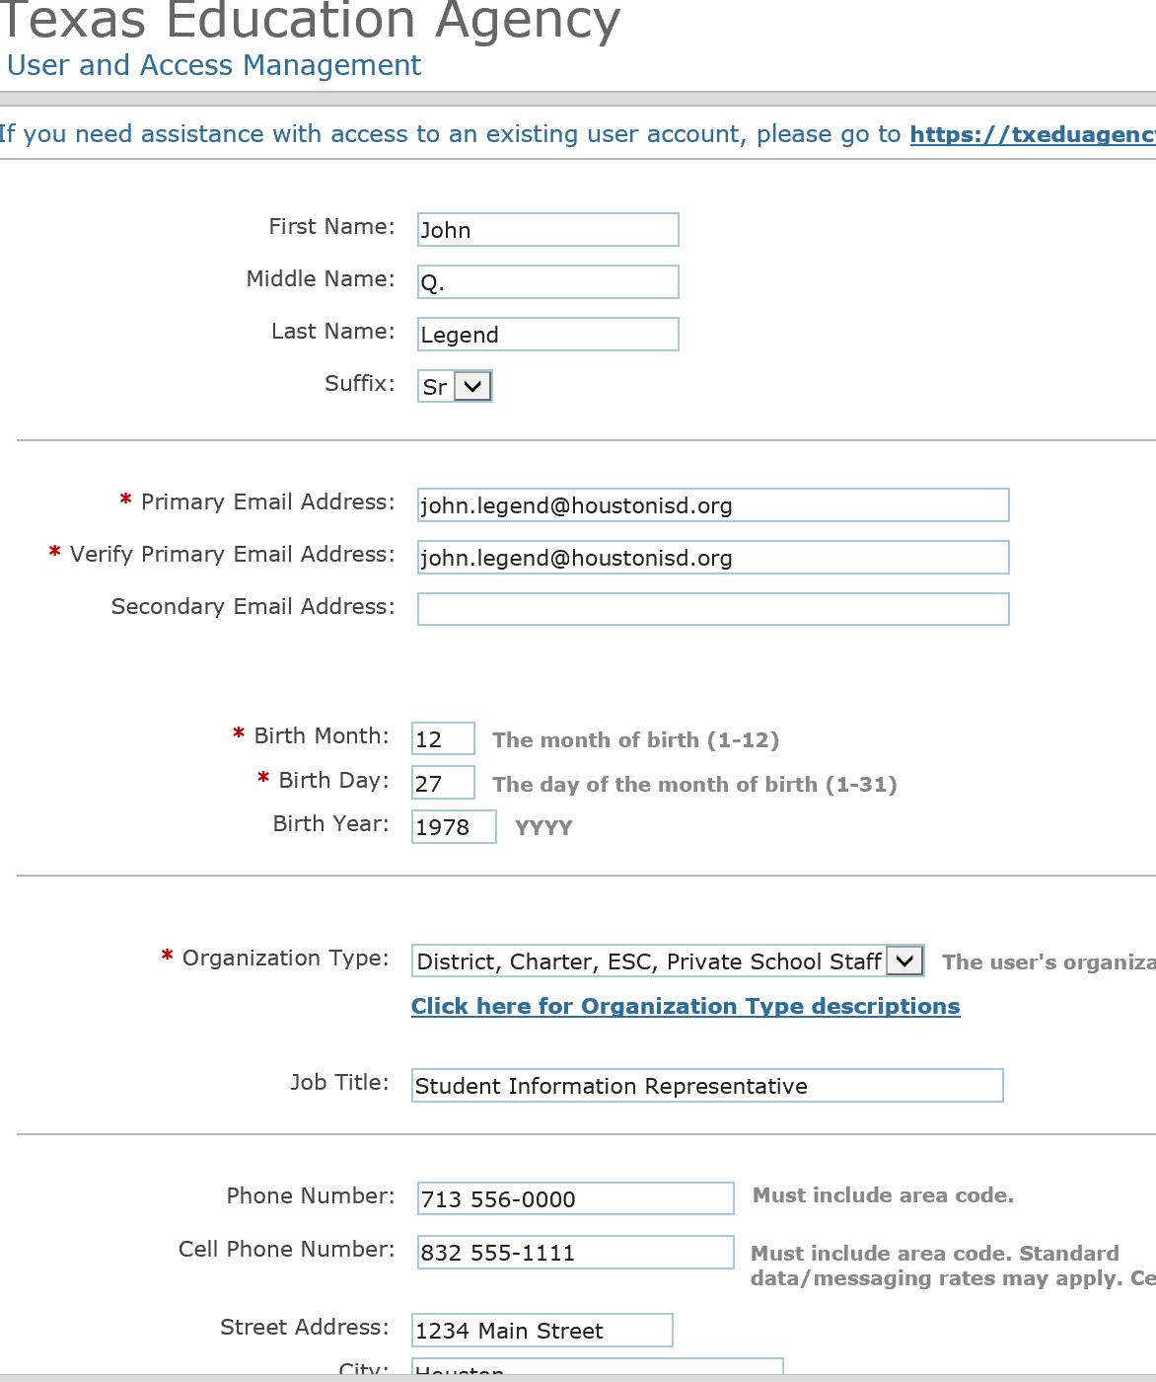

**Enter your HISD Email Address Only.**

**Do not enter personal email address, access will be denied.**

**Click Submit**

**Complete the HISD District PowerSchool Connect SIS Form for PowerSchool access.**